产品型号：DS240128-3手册
特性：
显示内容：240×128点
驱动方式：1/128Duty
可供型号：STN（黄绿模、灰模、蓝模）；全透型、反射型，EL背光/100V AC，400Hz；
LED背光/4.2V；CCFL背光。

外形尺寸图：
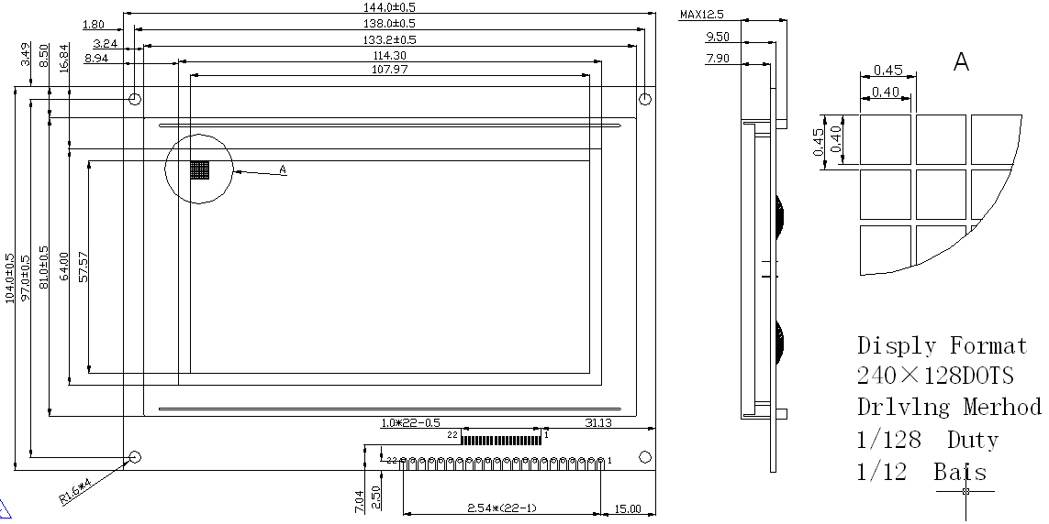

极限参数:
名称 | 符号 | 测试条件 | 标准值 |  | 单位
名称 | 符号 | 测试条件 | 最小值 | 最大值 | 单位
电源电压 | VDD-VSS | Ta=25℃ | 0 | 6 | V
LCD驱动电压 | VDD-V0 | Ta=25℃ | 0 | 28.0 | V
输入电压 | VI | Ta=25℃ | 0 | VDD | V

电参数:
名称 |  | 符号 | 测试条件 | 标准值 |  |  | 单位
 |  | 符号 | 测试条件 | 最小值 | 典型值 | 最大值 | 单位
电压 | 逻辑 | VDD-VSS | --- | 4.75 | 5.0 | 5.25 | V
电压 | LCD | VDD-V0 | --- | --- | 15.0 | --- | V
电流 | 逻辑 | IDD | --- | --- | 12.0 | --- | mA
电流 | LCD | IEE | --- | --- | 5.0 | --- | mA
LCD工作电压  (推荐值) |  | VDD-V0 | 0℃ | --- | 16.0 | --- | V
 |  | VDD-V0 | 25℃ | --- | 15.0 | --- | V
 |  | VDD-V0 | 40℃ | --- | 14.0 | --- | V
输入电压 | H高电平 | V_{IH} | 高电平 | 0.7 VDD | -- | VDD | V
输入电压 | L低电平 | V_{IL} | 低电平 | 0 | -- | 0.3VDD | V

接口引脚:
带T6963控制器接口
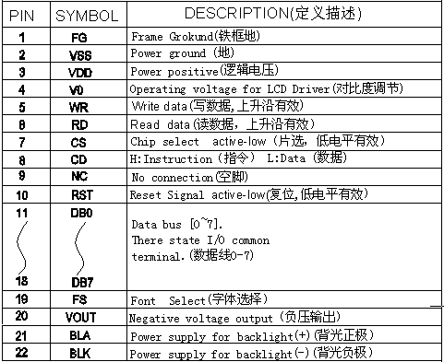

注意：
1、BLA（背光控制脚）：
在使用LED型背光时，作为LED背光电源正，板载降压电阻，可直接供给5V。第20脚和
第31脚同样功能，在带控制器接口中，LED背光的负极被接到GND（地）。
在使用EL背光和板载EL驱动器时，该脚则作为EL驱动控制脚，高电平有效。
在使用EL背光但外挂EL驱动器时，驱动电压则应由第31，32脚输入或直接接于EL背光
片引线端上。
2、BLK（背光负）
一般只在不带控制器时使用，作为背光低电压输入端（接地），当使用EL背光并且外挂驱动器时可作为EL驱动电压输入端。
3、VOUT（板载负压输出）
板载负压输出端，输出-12—20V负电压，以供驱动LCD使用，和V0间接可变电阻
（4.7K—20K）以调节对比度。
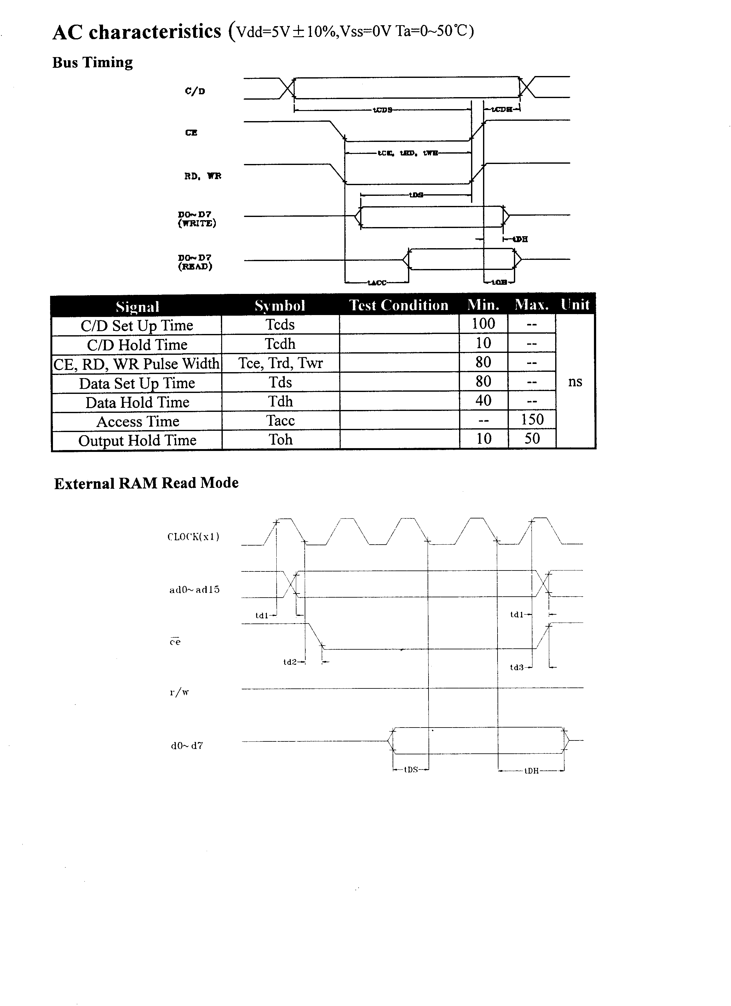
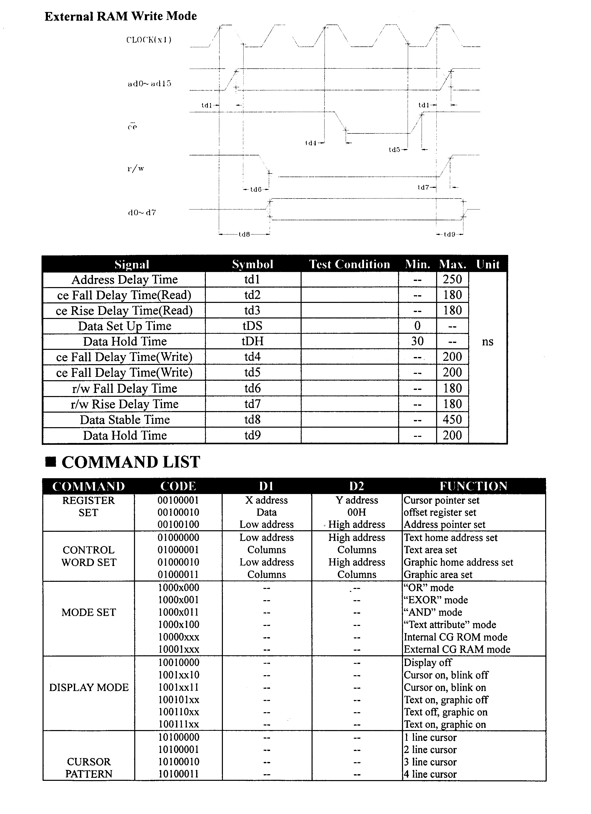
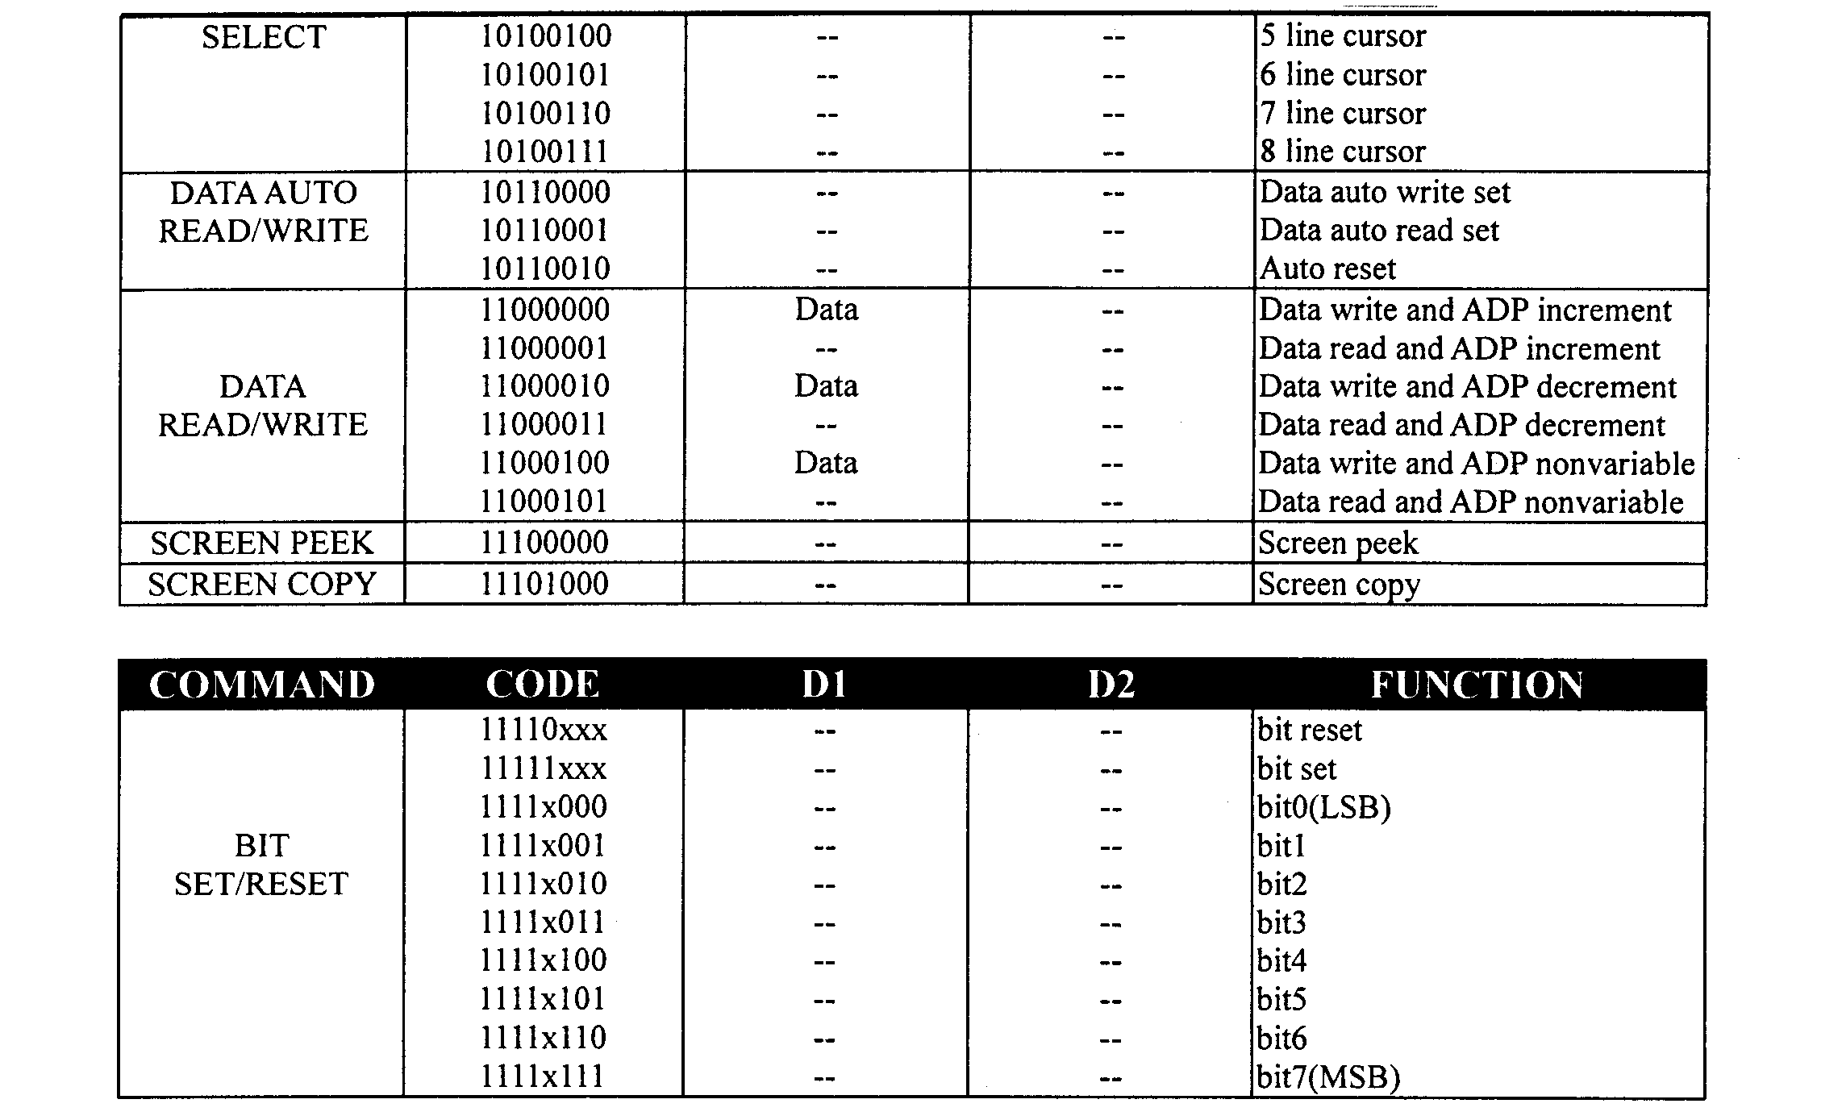

连接图：
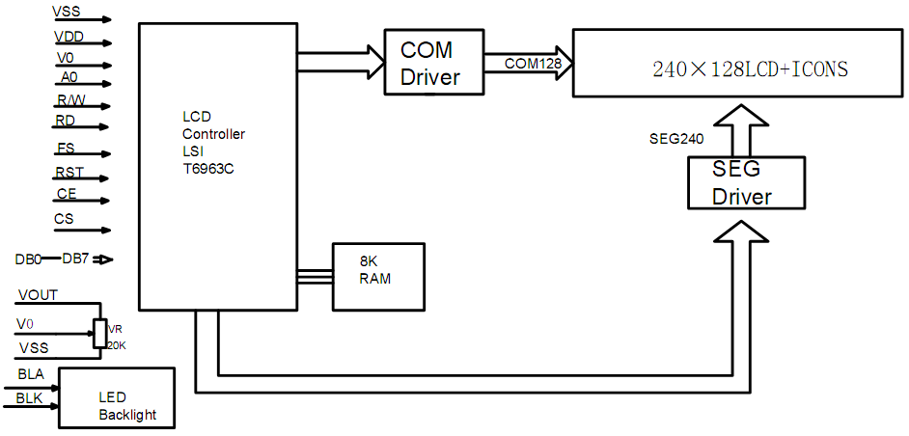
程序举例：
;------------------------------------------------------------------------------------------------------
PORTD EQU 0000H ;模块数据口地址(A15=0.A8=0)
PORTC EQU 0100H ;模块命令口地址(A15=0.A8=1)
FS BIT P3.5
KEY BIT P3.4
;------------------------------------------------------------------------------------------------------
ORG 0000H
LJMP MAIN
ORG 0030H
MAIN:
MOV SP,#60H ;设堆栈
CLR FS ;设字体为8X8
LCALL DEL_10MS ;模块上电复位
LCALL LCD_INT ;模块初始化7
NEXT: LCALL CLEAR
MOV DPTR,#BMP_DEMO
LCALL SCREEN ;显示一正屏位图
LCALL DEL_3S
LCALL d_dot1;SCREEN ;显示一正屏位图
LCALL DEL_3S
LCALL BLAK
LCALL DEL_3S
LCALL d_dot2;SCREEN ;显示一正屏位图
LCALL DEL_3S
AJMP MAIN ;观察效果
DEL_3S:
MOV R7,#10D
DEL2: MOV R6,#200D
DEL1: MOV R5,#200D
DEL0: JB KEY,DEGO
LJMP RKEY
DEGO:
DJNZ R5,DEL0
DJNZ R6,DEL1
DJNZ R7,DEL2
RET
RKEY: LCALL DEL_10MS
JB KEY,DEGO
HERR:
JNB KEY,HERR
LCALL DEL_10MS
JNB KEY,HERR
RET
MOV 35H,#00H
MOV TH0,#00H
MOV TL0,#00H
MOV TMOD,#01H
MOV IE,#82H
SETB TR0
CPUD: ORL PCON,#01H
NOP
MOV A,35H
CJNE A,#10D,CPUD
CLR TR0
RET

;--------------------------------------------------------------------------------
; 延时子程
;--------------------------------------------------------------------------------
DEL_10MS:
MOV R6,#10
DL2:
MOV R7,#200
DL1:
NOP
NOP
NOP
DJNZ R7,DL1
DJNZ R6,DL2
RET
;--------------------------------------------------------------------------------
; 写两个参数 （参数1在DPL中，参数2在DPH中）
;--------------------------------------------------------------------------------
WD2:
PUSH DPL
PUSH DPH
PUSH ACC
MOV A,DPL
LCALL WD1
MOV A,DPH
LCALL WD1
POP ACC
POP DPH
POP DPL
RET
;---------------------------------------------------------------------------------
; 写一个参数（参数在A中）
;---------------------------------------------------------------------------------
WD1:
PUSH DPL
PUSH DPH
PUSH ACC
PUSH ACC
LCALL CH_STA1
POP ACC
MOV DPTR,#PORTD
MOVX @DPTR,A
POP ACC
POP DPH
POP DPL
RET
;-----------------------------------------------------------------------------------
; 自动方式下写一个显示数据（数据在A中）
;-----------------------------------------------------------------------------------
AWD:
PUSH DPL
PUSH DPH
PUSH ACC
PUSH ACC
LCALL CH_STA3
POP ACC
MOV DPTR,#PORTD
MOVX @DPTR,A
POP ACC
POP DPH
POP DPL
RET
;-----------------------------------------------------------------------------------
; 写一个命令 （命令字在A中）
;-----------------------------------------------------------------------------------
WC:
PUSH DPL
PUSH DPH
PUSH ACC
PUSH ACC
LCALL CH_STA1
POP ACC
MOV DPTR,#PORTC
MOVX @DPTR,A
POP ACC
POP DPH
POP DPL
RET
;-----------------------------------------------------------------------------------
; 判断状态STA0,STA1
;-----------------------------------------------------------------------------------
CH_STA1:
PUSH DPL
PUSH DPH
PUSH ACC
MOV DPTR,#PORTC
CH_1:
MOVX A,@DPTR ;检查T6963状态字
ANL A,#03H ;要为0000 0011
CJNE A,#03H,CH_1
POP ACC
POP DPH
POP DPL
RET
;------------------------------------------------------------------------------------
; 判断状态3
;------------------------------------------------------------------------------------
CH_STA3:
PUSH DPL
PUSH DPH
PUSH ACC
MOV DPTR,#PORTC
CH_3:
MOVX A,@DPTR
ANL A,#08H
CJNE A,#08H,CH_3
POP ACC
POP DPH
POP DPL
RET
;--------------------------------------------------------------------------------------------
; LCD初始化
;--------------------------------------------------------------------------------------------
LCD_INT:
MOV DPTR,#00H ;图形显示区首地址为 00H；
LCALL WD2 ;写入两个参数；
MOV A,#42H ;
LCALL WC ;写入设置图形显示区首地址命令42H；
MOV DPTR,#001EH ;图形显示区宽度为30=240/8；
LCALL WD2 ;写入两个参数；
MOV A,#43H ;
LCALL WC ;写入设置图形显示区宽度命令43H；
MOV A,#80h ;
LCALL WC ;写入设置文本与图形逻辑"或"合成显示；
MOV A,#98H ;1001 1000
LCALL WC ;写入设置显示方式仅为图形显示；
RET
;--------------------------------------------------------------------------------------------
; 显示一幅240X128的黑白位图,位图在ROM中存放首地址在DPTR中
;--------------------------------------------------------------------------------------------
SCREEN:
PUSH DPL
PUSH DPH
MOV DPTR,#00H ;设置显缓写地址
LCALL WD2
MOV A,#24H
LCALL WC
MOV A,#0B0H ;设置进入显示数据自动写模式
LCALL WC
POP DPH
POP DPL
MOV R7,#128 ;共128行
GRAPH:
MOV R6,#30 ;每行30个字节
GRAPH1:
MOV A,#00H ;ROM中显示图形数据存放地址偏移量
MOVC A,@A+DPTR ;从ROM中取显示数据
LCALL AWD ;自动写一个显示数据，显缓地址指针自动加一
INC DPTR ;调整ROM数据指针
DJNZ R6,GRAPH1 ;一行未写完继续写
DJNZ R7,GRAPH ;128行未写完继续写
LCALL CH_STA3 ;检测状态3
MOV A,#0B2H ;
LCALL WC ;退出自动写模式
RET
;-----------------------------------------------------------------------------
; 清屏幕
;-----------------------------------------------------------------------------
CLEAR:

MOV DPTR,#00H ;设置显缓写地址
LCALL WD2
MOV A,#24H
LCALL WC
MOV A,#0B0H ;设置进入显示数据自动写模式
LCALL WC
MOV R7,#128 ;共128行
CLEAR1:
MOV R6,#30 ;每行30个字节
CLEAR2:
MOV A,#0FFH ;显示数据=0ffh
LCALL AWD ;自动写一个显示数据，显缓地址指针自动加一
DJNZ R6,CLEAR2 ;一行未写完继续写
DJNZ R7,CLEAR1 ;128行未写完继续写
LCALL CH_STA3 ;检测状态3
MOV A,#0B2H ;
LCALL WC ;退出自动写模式
RET

;*********************************************************
; 显示一黑屏
;*********************************************************
BLAK:
MOV DPTR,#00H ;设置显缓写地址
LCALL WD2
MOV A,#24H
LCALL WC
MOV A,#0B0H ;设置进入显示数据自动写模式
LCALL WC
MOV R7,#128 ;共128行
BLAK1:
MOV R6,#30 ;每行30个字节
BLAK2:
MOV A,#0FFH ;显示数据=0ffh
LCALL AWD ;自动写一个显示数据，显缓地址指针自动加一
DJNZ R6,BLAK2 ;一行未写完继续写
DJNZ R7,BLAK1 ;128行未写完继续写
LCALL CH_STA3 ;检测状态3
MOV A,#0B2H ;
LCALL WC ;退出自动写模式
RET
;*********************************************************
; 显示点阵屏1
;*********************************************************

D_DOT1:
MOV DPTR,#00H ;设置显缓写地址
LCALL WD2
MOV A,#24H
LCALL WC
MOV A,#0B0H ;设置进入显示数据自动写模式
LCALL WC
MOV R7,#64 ;
BLAK_1:
MOV R6,#30 ;每行30个字节
BLAK_2:
MOV A,#55H
LCALL AWD ;自动写一个显示数据，显缓地址指针自动加一
DJNZ R6,BLAK_2
MOV R6,#30
BLAK_22:
MOV A,#0AAH
LCALL AWD ;自动写一个显示数据，显缓地址指针自动加一
DJNZ R6,BLAK_22
DJNZ R7,BLAK_1
LCALL CH_STA3 ;检测状态3
MOV A,#0B2H ;
LCALL WC ;退出自动写模式
RET
;*********************************************************
; 显示点阵屏2
;*********************************************************
D_DOT2:
MOV DPTR,#00H ;设置显缓写地址
LCALL WD2
MOV A,#24H
LCALL WC
MOV A,#0B0H ;设置进入显示数据自动写模式
LCALL WC
MOV R7,#64
BLAK_21:
MOV R6,#30 ;每行30个字节
BLAK_222:
MOV A,#0AAH
LCALL AWD ;自动写一个显示数据，显缓地址指针自动加一
DJNZ R6,BLAK_222
MOV R6,#30
BLAK_223:
MOV A,#055H
LCALL AWD ;自动写一个显示数据，显缓地址指针自动加一
DJNZ R6,BLAK_223 ;
DJNZ R7,BLAK_21
LCALL CH_STA3 ;检测状态3
MOV A,#0B2H ;
LCALL WC ;退出自动写模式
RET

BMP_DEMO:

;-- 调入了一幅图像：C:\Documents and Settings\liujun\My Documents\My Pictures\240128\1.bmp --
;-- 宽度x高度=240x128 --
DB 0FFH,0FFH,0FFH,0FFH,0FFH,0FFH,0FFH,0FFH,0FFH,0FFH,0FFH,0FFH,0FFH,0FFH,0FFH,0FFH
DB 0FFH,0FFH,0FFH,0FFH,0FFH,0FFH,0FFH,0FFH,0FFH,0FFH,0FFH,0FFH,0FFH,0FFH,080H,000H
DB 000H,000H,000H,000H,000H,000H,000H,000H,000H,000H,000H,000H,000H,000H,000H,000H
DB 000H,000H,000H,000H,000H,000H,000H,000H,000H,000H,000H,001H,0BFH,0FFH,0FFH,0FFH
DB 0FFH,0FFH,0FFH,0FFH,0FFH,0FFH,0FFH,0FFH,0FFH,0FFH,0FFH,0FFH,0FFH,0FFH,0FFH,0FFH
DB 0FFH,0FFH,0FFH,0FFH,0FFH,0FFH,0FFH,0FFH,0FFH,0FDH,0A2H,040H,000H,000H,000H,000H
DB 000H,000H,000H,000H,000H,000H,000H,000H,000H,000H,000H,000H,000H,000H,000H,000H
DB 000H,000H,000H,000H,000H,000H,002H,045H,0A4H,080H,000H,000H,000H,000H,000H,000H
DB 000H,000H,000H,000H,000H,000H,000H,000H,000H,000H,000H,000H,000H,000H,000H,000H
DB 000H,000H,000H,000H,001H,025H,0A9H,000H,000H,000H,000H,000H,000H,000H,000H,000H
DB 000H,000H,000H,000H,000H,000H,000H,000H,000H,000H,000H,000H,000H,000H,000H,000H
DB 000H,000H,000H,095H,0B2H,000H,000H,000H,000H,000H,000H,000H,01CH,000H,000H,000H
DB 000H,000H,000H,000H,000H,000H,000H,000H,000H,000H,000H,000H,020H,000H,000H,000H
DB 000H,04DH,0A4H,002H,021H,0E0H,000H,000H,008H,000H,00EH,000H,000H,000H,000H,000H
DB 000H,000H,000H,000H,000H,000H,003H,080H,000H,020H,020H,000H,003H,000H,000H,025H
DB 0A8H,003H,017H,0B0H,002H,000H,00CH,000H,007H,0FCH,000H,020H,000H,000H,00CH,000H
DB 000H,030H,000H,000H,026H,0C0H,000H,070H,020H,000H,003H,080H,000H,015H,0B0H,001H
DB 0BEH,030H,001H,080H,00CH,000H,07FH,0FCH,000H,030H,000H,000H,006H,000H,000H,038H
DB 000H,000H,03CH,0C0H,000H,0F7H,060H,000H,0C1H,080H,000H,00DH,0A0H,001H,0BBH,0E0H
DB 001H,080H,008H,00FH,0C6H,000H,000H,030H,000H,000H,007H,000H,000H,038H,000H,000H
DB 079H,0C0H,003H,0C7H,0A0H,000H,061H,080H,000H,005H,0A0H,003H,065H,080H,001H,0C0H
DB 028H,00FH,006H,000H,000H,030H,03CH,000H,007H,000H,000H,018H,000H,000H,0F3H,080H
DB 004H,0CBH,020H,000H,061H,080H,000H,005H,0A0H,004H,059H,0C0H,003H,0EDH,0A8H,004H
DB 006H,000H,000H,078H,0DCH,000H,007H,000H,000H,01FH,080H,000H,0EFH,000H,000H,0FEH
DB 020H,000H,061H,0F0H,000H,005H,0A0H,004H,05DH,0C0H,007H,0CEH,0C8H,000H,06FH,0E0H
DB 000H,0F7H,09CH,000H,006H,000H,000H,078H,060H,000H,0DEH,000H,001H,0EFH,030H,000H
DB 063H,0E0H,000H,005H,0A0H,006H,01BH,000H,00FH,01AH,0C8H,000H,07FH,0E0H,003H,0F7H
DB 030H,000H,006H,000H,004H,0D8H,0E0H,000H,01FH,000H,027H,0CBH,03CH,001H,0F7H,080H
DB 000H,005H,0A0H,006H,01FH,0E0H,007H,01CH,088H,000H,036H,070H,00FH,0FEH,060H,000H
DB 006H,00CH,007H,03CH,0F0H,000H,00BH,0C0H,01FH,0DEH,0E0H,003H,0CFH,000H,000H,005H
DB 0A0H,006H,01FH,000H,003H,01CH,088H,000H,066H,060H,00FH,0B6H,0C0H,004H,006H,006H
DB 007H,07FH,0E0H,000H,00FH,0F0H,00EH,0DDH,0E0H,01FH,0DBH,000H,000H,005H,0A0H,006H
DB 03FH,000H,003H,0C9H,088H,000H,066H,060H,007H,071H,080H,004H,006H,006H,007H,0F9H
DB 0C0H,000H,071H,0F0H,004H,0F3H,020H,00FH,073H,0E0H,000H,005H,0A0H,004H,0FFH,000H
DB 007H,0C9H,088H,000H,0E6H,060H,000H,0E3H,090H,006H,006H,006H,003H,03BH,080H,000H
DB 0E1H,080H,001H,0DEH,020H,002H,061H,060H,000H,005H,0A0H,004H,08FH,0C0H,00FH,019H
DB 088H,000H,0E7H,060H,001H,0C3H,098H,006H,006H,006H,003H,0FFH,000H,001H,0C1H,080H
DB 007H,08CH,020H,000H,0FCH,060H,000H,005H,0A0H,007H,099H,0F0H,00EH,011H,008H,000H
DB 047H,0E0H,003H,0C7H,0FCH,003H,007H,0FEH,003H,0FFH,000H,001H,081H,080H,007H,080H
DB 020H,003H,0CFH,0C0H,000H,005H,0A0H,007H,0B1H,038H,008H,030H,008H,000H,006H,0C0H
DB 003H,047H,0CCH,003H,07FH,0FEH,001H,0FFH,000H,001H,001H,080H,006H,080H,020H,007H
DB 0C1H,0C0H,000H,005H,0A0H,003H,0E1H,00CH,000H,020H,008H,000H,004H,040H,003H,047H
DB 004H,007H,0FEH,00CH,001H,0F0H,000H,001H,001H,080H,000H,080H,020H,00FH,0C3H,0F0H
DB 000H,005H,0A0H,003H,045H,000H,000H,000H,018H,000H,004H,000H,000H,040H,004H,007H
DB 0C0H,00CH,000H,030H,000H,000H,0C1H,080H,000H,080H,020H,006H,0FFH,0FCH,000H,005H
DB 0A0H,001H,007H,000H,000H,000H,018H,000H,004H,000H,000H,040H,000H,007H,080H,00CH
DB 000H,01FH,0C0H,000H,023H,000H,000H,040H,020H,001H,0C6H,01EH,000H,005H,0A0H,000H
DB 003H,000H,000H,000H,008H,000H,004H,000H,000H,040H,000H,002H,000H,000H,000H,00FH
DB 0E0H,000H,01FH,000H,000H,000H,020H,000H,0C0H,006H,000H,005H,0A0H,000H,000H,000H
DB 000H,000H,008H,000H,004H,000H,000H,000H,000H,000H,000H,000H,000H,000H,000H,000H
DB 006H,000H,000H,000H,020H,000H,040H,002H,000H,005H,0A0H,000H,000H,000H,000H,000H
DB 000H,000H,004H,000H,000H,000H,000H,000H,000H,000H,000H,000H,000H,000H,000H,000H
DB 000H,000H,020H,000H,000H,000H,000H,005H,0A0H,000H,000H,000H,000H,000H,000H,000H
DB 004H,000H,000H,000H,000H,000H,000H,000H,000H,000H,000H,000H,000H,000H,000H,000H
DB 020H,000H,000H,000H,000H,005H,0A0H,000H,000H,000H,000H,000H,000H,000H,000H,000H
DB 000H,000H,000H,000H,000H,000H,000H,000H,000H,000H,000H,000H,000H,000H,000H,000H
DB 000H,000H,000H,005H,0A0H,000H,000H,000H,000H,000H,000H,000H,000H,000H,000H,000H
DB 000H,000H,000H,000H,000H,000H,000H,000H,000H,000H,000H,000H,000H,000H,000H,000H
DB 000H,005H,0A0H,000H,000H,000H,000H,000H,000H,000H,000H,000H,000H,000H,000H,000H
DB 000H,000H,000H,000H,000H,000H,000H,000H,000H,000H,000H,000H,000H,000H,000H,005H
DB 0A0H,000H,000H,000H,000H,000H,000H,000H,000H,000H,000H,000H,000H,000H,000H,000H
DB 000H,000H,000H,000H,000H,000H,000H,000H,000H,000H,000H,000H,000H,005H,0A0H,000H
DB 000H,000H,000H,000H,000H,000H,000H,000H,000H,000H,000H,000H,000H,000H,000H,000H
DB 000H,000H,000H,000H,000H,000H,000H,000H,000H,000H,000H,005H,0A0H,000H,000H,000H
DB 000H,000H,000H,000H,000H,000H,000H,000H,000H,000H,000H,000H,000H,000H,000H,000H
DB 000H,000H,000H,000H,000H,000H,000H,000H,000H,005H,0A0H,000H,000H,000H,000H,000H
DB 000H,000H,000H,000H,000H,000H,000H,000H,000H,000H,000H,000H,000H,000H,000H,000H
DB 000H,000H,000H,000H,000H,000H,000H,005H,0A0H,000H,000H,000H,000H,000H,000H,000H
DB 000H,000H,000H,000H,000H,000H,000H,000H,000H,000H,000H,000H,000H,000H,000H,000H
DB 000H,000H,000H,000H,000H,005H,0A0H,000H,000H,000H,0D7H,0E4H,000H,000H,000H,000H
DB 000H,000H,000H,000H,001H,0FFH,000H,000H,000H,000H,000H,000H,000H,000H,000H,000H
DB 000H,000H,000H,005H,0A0H,000H,000H,008H,000H,000H,0C0H,000H,000H,000H,000H,007H
DB 080H,000H,001H,0BFH,0E0H,000H,000H,000H,000H,000H,000H,000H,000H,000H,000H,000H
DB 000H,005H,0A0H,000H,000H,000H,000H,000H,008H,000H,000H,000H,000H,0FFH,0E0H,000H
DB 000H,01FH,0FCH,000H,000H,000H,000H,000H,000H,000H,000H,000H,000H,000H,000H,005H
DB 0A0H,000H,000H,000H,000H,000H,002H,000H,000H,000H,007H,0FFH,0C0H,000H,008H,01FH
DB 0FFH,000H,000H,000H,000H,000H,000H,000H,03FH,080H,000H,000H,000H,005H,0A0H,000H
DB 000H,000H,000H,000H,000H,040H,000H,000H,03FH,0FFH,000H,000H,000H,04FH,0FFH,0C0H
DB 000H,000H,003H,000H,000H,001H,0FFH,0F0H,000H,000H,000H,005H,0A0H,000H,000H,000H
DB 000H,000H,000H,020H,000H,001H,0FFH,0FCH,000H,080H,000H,04FH,0FFH,0E0H,000H,000H
DB 004H,000H,000H,003H,0FCH,006H,000H,000H,000H,005H,0A0H,000H,000H,000H,000H,000H
DB 000H,010H,000H,0C3H,0FFH,0F8H,083H,0F0H,080H,04FH,0DFH,0F8H,000H,000H,008H,000H
DB 000H,00FH,07FH,0F9H,0C0H,000H,000H,005H,0A0H,000H,000H,000H,000H,000H,000H,008H
DB 000H,0E0H,0FFH,0F8H,001H,026H,000H,04FH,003H,0FCH,000H,000H,010H,000H,000H,003H
DB 0FFH,0FFH,0F8H,000H,000H,005H,0A0H,000H,000H,000H,000H,000H,000H,004H,000H,0F0H
DB 0FCH,00AH,067H,0FFH,0C0H,04CH,001H,0F6H,000H,000H,010H,000H,000H,000H,07FH,0FFH
DB 0FEH,000H,000H,005H,0A0H,000H,000H,000H,000H,000H,000H,000H,000H,0F9H,0E0H,03BH
DB 0FFH,0FFH,0E0H,000H,000H,0B9H,000H,000H,020H,000H,000H,000H,03FH,0FFH,0FFH,000H
DB 000H,005H,0A0H,000H,000H,000H,000H,000H,000H,000H,000H,0FFH,0C0H,0FFH,0FFH,0FFH
DB 0FCH,053H,000H,04CH,000H,000H,020H,000H,000H,000H,00FH,0FFH,0FFH,080H,000H,005H
DB 0A0H,000H,000H,000H,000H,000H,000H,001H,000H,0FFH,0C0H,03FH,0FFH,0FFH,0FEH,070H
DB 000H,026H,000H,000H,020H,000H,000H,000H,007H,0FFH,0FFH,0C0H,000H,005H,0A0H,020H
DB 000H,000H,000H,000H,000H,000H,000H,03FH,080H,07FH,0FFH,0FFH,0FFH,000H,000H,019H
DB 080H,000H,010H,000H,080H,000H,000H,007H,0FFH,0F0H,000H,005H,0A0H,040H,000H,000H
DB 000H,000H,000H,000H,080H,01FH,080H,07FH,0FFH,0FFH,0FFH,080H,000H,08CH,0C0H,000H
DB 000H,000H,000H,004H,004H,001H,0FFH,0F8H,020H,005H,0A0H,080H,000H,000H,000H,000H
DB 000H,000H,080H,00FH,080H,03FH,0FFH,0FEH,07FH,080H,000H,006H,060H,000H,008H,000H
DB 000H,00CH,00CH,0A0H,0FFH,0F8H,000H,005H,0A1H,000H,000H,000H,000H,000H,000H,000H
DB 040H,003H,002H,03DH,0FFH,09DH,01FH,080H,008H,001H,030H,000H,000H,000H,000H,018H
DB 01BH,034H,03FH,0FCH,010H,005H,0A1H,000H,000H,000H,000H,000H,000H,000H,040H,003H
DB 002H,03DH,0FFH,0DCH,08FH,0D0H,06CH,004H,0B0H,000H,000H,000H,000H,030H,03BH,014H
DB 00FH,0FFH,008H,005H,0A0H,000H,000H,004H,000H,000H,000H,000H,040H,007H,000H,05BH
DB 0FFH,0E2H,007H,0C0H,040H,000H,058H,000H,000H,000H,000H,060H,07BH,0D6H,007H,0FFH
DB 000H,005H,0A0H,000H,000H,000H,000H,000H,000H,000H,000H,006H,040H,097H,0BFH,0F0H
DB 001H,0E0H,000H,008H,06CH,000H,000H,020H,000H,0C4H,0F7H,0D6H,083H,0FFH,080H,005H
DB 0A0H,002H,000H,028H,010H,020H,000H,000H,020H,00EH,040H,027H,07FH,090H,000H,0E1H
DB 081H,0C8H,034H,000H,000H,040H,001H,08CH,0EFH,0D2H,081H,0FFH,080H,005H,0A4H,042H
DB 000H,008H,090H,000H,010H,000H,020H,00EH,000H,04EH,0DFH,0C8H,000H,0E0H,060H,0C4H
DB 018H,000H,000H,080H,003H,099H,0DEH,0DAH,080H,0FFH,0C0H,005H,0A4H,044H,000H,009H
DB 090H,010H,008H,000H,020H,00FH,088H,0CDH,0D3H,08CH,009H,070H,030H,0C6H,018H,000H
DB 001H,000H,007H,013H,0D2H,0DBH,0C0H,07FH,0C0H,005H,0A8H,044H,000H,011H,093H,000H
DB 008H,000H,020H,01FH,080H,099H,0A1H,056H,00CH,0B0H,033H,003H,00CH,000H,001H,020H
DB 00FH,037H,0E2H,0DBH,0C0H,03FH,0E0H,005H,0A0H,084H,000H,011H,013H,088H,004H,000H
DB 000H,01FH,0D5H,0BBH,021H,0ABH,006H,078H,003H,009H,084H,000H,002H,060H,00EH,067H
DB 0A2H,0FBH,040H,01FH,0E0H,005H,0B1H,08CH,020H,031H,002H,0C1H,006H,000H,000H,007H
DB 0F9H,036H,040H,0AFH,003H,078H,002H,00CH,0E2H,000H,006H,040H,01EH,06FH,0C3H,0FBH
DB 060H,00FH,0E0H,005H,0B1H,00CH,060H,031H,002H,080H,082H,001H,000H,00FH,0FBH,036H
DB 040H,017H,083H,0B8H,000H,00EH,078H,000H,004H,080H,03CH,0CFH,043H,039H,060H,02FH
DB 0F0H,005H,0B1H,028H,060H,021H,020H,0A0H,003H,000H,010H,00FH,0F2H,06CH,080H,01BH
DB 0D9H,0FCH,010H,00EH,07CH,000H,00DH,080H,03CH,0DEH,083H,039H,0E0H,027H,0F0H,005H
DB 0A3H,009H,000H,062H,000H,010H,001H,000H,000H,00DH,0F6H,068H,080H,00DH,0CCH,0FCH
DB 000H,03FH,03CH,000H,001H,080H,078H,0DFH,083H,039H,0E0H,007H,0F0H,005H,0A3H,040H
DB 000H,065H,000H,040H,040H,080H,000H,00BH,0F6H,0F8H,080H,00FH,0EEH,0FEH,000H,027H
DB 0BCH,000H,013H,000H,0F9H,0BFH,003H,039H,0F0H,003H,0F0H,005H,0A2H,048H,000H,065H
DB 000H,040H,020H,080H,000H,00BH,0FEH,0F0H,080H,0BFH,0F7H,0FEH,000H,067H,0FEH,000H
DB 023H,001H,0FBH,0FBH,006H,038H,0F0H,033H,0F8H,005H,0A2H,048H,000H,064H,000H,048H
DB 030H,0C0H,000H,003H,0EDH,0F7H,080H,0F4H,0B7H,0FFH,081H,033H,0FEH,000H,00EH,005H
DB 0F3H,0FEH,006H,038H,0F0H,039H,0F8H,005H,0A6H,0C8H,000H,065H,040H,025H,0D8H,040H
DB 000H,003H,0FDH,0FDH,080H,046H,01BH,0FFH,0F1H,019H,0FEH,000H,04CH,005H,0F3H,0F6H
DB 006H,018H,070H,03DH,0F8H,005H,0A4H,089H,000H,0EDH,0C0H,026H,008H,000H,000H,003H
DB 0FFH,0F8H,008H,002H,01FH,0FFH,0FFH,008H,0FEH,000H,048H,005H,0FFH,0E4H,006H,03EH
DB 078H,03CH,0F8H,005H,0A4H,088H,001H,0E7H,082H,021H,004H,020H,000H,007H,0FFH,0F0H
DB 008H,003H,08FH,0FFH,0FFH,08CH,0FEH,000H,05AH,00BH,0FFH,0ECH,004H,03FH,078H,03CH
DB 0FCH,005H,0A8H,088H,000H,0C0H,0C0H,010H,0C6H,000H,000H,007H,0FFH,0E3H,080H,007H
DB 0EFH,0FFH,0FFH,0C6H,07CH,000H,0D2H,00BH,0FFH,0C8H,00CH,018H,078H,03CH,0BCH,005H
DB 0A8H,088H,020H,0C0H,0C6H,010H,000H,010H,000H,00FH,0FFH,0E3H,0C0H,00DH,0F7H,0FFH
DB 0FFH,0E3H,078H,000H,090H,01FH,0EFH,088H,00CH,018H,03CH,03FH,09CH,005H,0A0H,089H
DB 020H,0E4H,0C6H,010H,000H,000H,000H,00FH,0FFH,0E7H,0E0H,00BH,0B3H,0FFH,0FFH,0FBH
DB 078H,000H,094H,097H,0EFH,098H,00CH,01EH,03FH,03FH,01CH,005H,0A8H,089H,020H,0E4H
DB 0C2H,008H,07FH,000H,000H,003H,0FFH,0E5H,020H,003H,09BH,0FFH,0FFH,0FFH,0B0H,000H
DB 0A4H,09FH,0DFH,098H,00CH,01EH,03FH,0BEH,01BH,005H,0B1H,089H,0A0H,0E4H,042H,001H
DB 0FFH,0E0H,000H,007H,0FFH,0EDH,0A0H,003H,0C9H,0FFH,0FFH,0FFH,0BCH,000H,025H,0BFH
DB 0DFH,0FCH,018H,01EH,034H,0FCH,01BH,005H,0A0H,088H,0A0H,0D4H,040H,00BH,0FFH,0F8H
DB 000H,007H,0FFH,0E5H,0E0H,003H,0FDH,0FFH,0FFH,0FFH,0F8H,000H,029H,0FFH,0DFH,0BCH
DB 018H,01EH,016H,0FCH,01AH,005H,0A0H,088H,0A0H,07FH,0C0H,00EH,0FFH,0FCH,000H,001H
DB 03FH,0F5H,0E0H,003H,0FCH,0FFH,0FFH,0FFH,0F8H,000H,00BH,0FFH,0FFH,00CH,010H,01FH
DB 017H,0BEH,026H,005H,0A0H,08CH,0B0H,07FH,0C0H,00CH,0FFH,0DCH,010H,001H,033H,0F5H
DB 0E0H,001H,0FEH,0FFH,0FFH,0FFH,0F8H,000H,00FH,0FDH,0FEH,00EH,030H,01FH,0B3H,0BFH
DB 02EH,005H,0A9H,089H,0D0H,0FFH,0E0H,000H,0FFH,0DCH,050H,001H,033H,0F0H,0E0H,000H
DB 0F8H,0FFH,0BFH,0FFH,0E8H,000H,001H,0FFH,0BCH,00EH,020H,003H,0FBH,0FEH,04FH,005H
DB 0A9H,08DH,0E1H,0BFH,0E0H,000H,0FFH,0CCH,008H,001H,033H,0F0H,000H,001H,0C0H,0FFH
DB 0BFH,0FFH,0E8H,000H,003H,0F7H,0FCH,01EH,020H,001H,0FBH,0FEH,08FH,005H,0A1H,08DH
DB 0EFH,03FH,0E0H,000H,07FH,0C8H,008H,001H,033H,0F8H,0E0H,000H,0F0H,0FDH,0DDH,0BFH
DB 0E0H,000H,007H,0F3H,0F8H,09EH,000H,001H,0FBH,0FEH,08FH,005H,0A1H,04CH,0F3H,03FH
DB 0E0H,000H,07EH,002H,008H,001H,031H,0F8H,080H,000H,021H,0FFH,0CCH,09FH,0F0H,000H
DB 009H,0E7H,0D9H,0FEH,000H,001H,0FFH,0FFH,0CFH,085H,0A1H,044H,0F3H,03FH,0E0H,000H
DB 07EH,003H,008H,001H,011H,0B8H,000H,000H,001H,0FFH,0CEH,0DFH,0F0H,000H,003H,0CEH
DB 0D9H,0F6H,000H,001H,0F7H,0FFH,0EFH,085H,0A1H,046H,0F3H,01FH,080H,000H,03FH,0C3H
DB 000H,000H,011H,038H,000H,000H,001H,0FFH,0C6H,04FH,0F0H,000H,01FH,09CH,050H,0F6H
DB 000H,037H,0F7H,0FFH,0DFH,085H,0A1H,02AH,0A9H,01FH,080H,000H,01FH,082H,000H,000H
DB 010H,03CH,000H,000H,003H,0FFH,0C6H,047H,0F0H,000H,03FH,098H,050H,0FEH,000H,03FH
DB 0F3H,0FFH,0CFH,095H,0A7H,0B3H,0F0H,01FH,080H,000H,00FH,007H,000H,000H,008H,03CH
DB 000H,0E0H,003H,0FFH,0E2H,067H,0F0H,000H,05FH,038H,040H,07CH,000H,03FH,0B3H,0FEH
DB 0CFH,0D5H,0A0H,0F2H,0F0H,00FH,0E0H,000H,000H,007H,080H,000H,008H,07CH,007H,0E0H
DB 003H,0FFH,0E2H,027H,0F0H,000H,0DEH,078H,048H,07CH,000H,01FH,033H,0FCH,06EH,0D5H
DB 0A0H,031H,0B0H,00FH,0C0H,000H,000H,007H,088H,000H,000H,078H,007H,0E0H,007H,0FFH
DB 0E2H,023H,0F0H,000H,03CH,0F8H,040H,038H,000H,01FH,0F3H,0F8H,02FH,0D5H,0A0H,000H
DB 098H,007H,080H,000H,000H,00CH,000H,000H,000H,0F9H,003H,0E0H,007H,0FFH,0FAH,022H
DB 0F0H,000H,079H,0FCH,040H,000H,000H,01FH,0E3H,077H,03FH,0D5H,0A0H,000H,048H,000H
DB 000H,000H,000H,01CH,0C0H,000H,000H,0F1H,083H,0E0H,007H,0FFH,0FCH,022H,0E0H,000H
DB 072H,0F4H,040H,000H,000H,00FH,0E3H,060H,09FH,0D5H,0A0H,000H,048H,000H,000H,000H
DB 000H,01DH,080H,000H,000H,071H,0C1H,0C0H,007H,0FFH,0FEH,022H,0E0H,000H,0E7H,0F2H
DB 040H,000H,000H,007H,0C6H,040H,01FH,0D5H,0A0H,008H,008H,000H,000H,000H,000H,039H
DB 000H,000H,000H,063H,080H,0C0H,00FH,0FFH,0FFH,022H,0E0H,021H,0CDH,0F3H,0C0H,000H
DB 000H,000H,000H,040H,01FH,0D5H,0A0H,008H,0C4H,000H,000H,000H,000H,030H,000H,000H
DB 000H,063H,018H,000H,00FH,0FFH,047H,0C0H,0C0H,001H,0BBH,0E3H,0C0H,000H,000H,000H
DB 000H,0C4H,01FH,0F5H,0A0H,004H,024H,000H,000H,000H,000H,0E0H,000H,003H,000H,0C6H
DB 03CH,000H,00FH,0FEH,003H,0E0H,080H,01BH,073H,0E6H,060H,000H,000H,000H,001H,0C0H
DB 01FH,0F5H,0A0H,002H,03EH,000H,000H,002H,001H,0C0H,000H,003H,000H,088H,03EH,000H
DB 00FH,0FEH,003H,0E5H,000H,023H,0F3H,0ECH,060H,000H,000H,000H,001H,040H,03FH,0F5H
DB 0A0H,001H,0BBH,000H,000H,048H,003H,080H,000H,002H,000H,000H,0FFH,060H,00FH,0FEH
DB 011H,0C5H,010H,007H,0A7H,0C8H,070H,000H,061H,080H,003H,020H,03FH,0F5H,0A0H,000H
DB 011H,080H,000H,000H,007H,080H,000H,000H,000H,001H,0FCH,000H,017H,0FCH,011H,0C4H
DB 020H,007H,007H,0D8H,0F8H,000H,000H,080H,007H,0F0H,05FH,0F5H,0A0H,000H,009H,0E0H
DB 000H,000H,01DH,080H,000H,000H,000H,003H,080H,000H,007H,0ECH,008H,088H,020H,002H
DB 02FH,0C8H,0FEH,000H,000H,080H,008H,0FFH,09FH,0E5H,0A0H,000H,000H,078H,000H,000H
DB 075H,0C0H,000H,000H,000H,002H,000H,000H,007H,018H,008H,008H,020H,000H,04FH,0FCH
DB 0EFH,000H,020H,080H,010H,0F8H,01FH,0E5H,0A0H,000H,000H,04FH,000H,001H,0E5H,0C0H
DB 000H,000H,000H,008H,000H,000H,004H,000H,004H,001H,010H,000H,05FH,080H,000H,080H
DB 000H,000H,061H,0FFH,0FFH,085H,0A0H,000H,000H,04AH,0F8H,007H,0A5H,080H,000H,000H
DB 000H,000H,020H,0C0H,000H,000H,004H,011H,00CH,000H,03EH,000H,000H,060H,011H,001H
DB 0E1H,0B8H,000H,005H,0A0H,000H,000H,04AH,01FH,0FEH,024H,0C4H,000H,000H,000H,000H
DB 070H,0C0H,000H,000H,002H,023H,083H,000H,040H,000H,000H,01FH,000H,01FH,070H,000H
DB 000H,005H,0A0H,000H,000H,018H,01DH,0FFH,0FCH,0C0H,000H,000H,000H,000H,000H,000H
DB 000H,000H,002H,021H,0C0H,000H,000H,000H,001H,023H,0FFH,0EEH,000H,000H,000H,005H
DB 0A0H,000H,000H,010H,01FH,0FFH,0FCH,0C0H,000H,000H,000H,000H,000H,000H,000H,008H
DB 000H,000H,000H,000H,000H,000H,003H,020H,007H,0C4H,000H,000H,000H,005H,0A0H,000H
DB 000H,090H,017H,0FFH,0FCH,0C0H,000H,000H,000H,000H,000H,000H,000H,010H,021H,040H
DB 000H,000H,000H,000H,007H,090H,00FH,008H,080H,000H,000H,005H,0A0H,000H,000H,090H
DB 017H,0FFH,0FEH,0C0H,000H,000H,000H,000H,008H,000H,000H,000H,001H,080H,000H,000H
DB 000H,000H,007H,088H,008H,00CH,000H,000H,000H,005H,0A0H,000H,000H,0A0H,037H,0FFH
DB 0FEH,0E0H,000H,000H,000H,003H,000H,000H,000H,000H,000H,082H,030H,000H,000H,000H
DB 00FH,0C0H,008H,000H,001H,000H,000H,005H,0A0H,000H,001H,080H,027H,0FFH,0FEH,020H
DB 000H,000H,000H,000H,000H,000H,000H,004H,002H,000H,00BH,000H,000H,000H,00FH,0E4H
DB 000H,000H,002H,000H,000H,005H,0A0H,000H,001H,0A0H,00FH,0FFH,0FEH,001H,000H,000H
DB 000H,000H,000H,000H,000H,000H,000H,000H,000H,000H,000H,000H,00FH,0F0H,000H,0F4H
DB 002H,0C0H,000H,005H,0A0H,000H,003H,020H,01FH,0FFH,0FEH,081H,000H,000H,000H,030H
DB 000H,000H,000H,000H,000H,000H,000H,000H,000H,000H,00FH,0F2H,007H,0FCH,004H,0C0H
DB 000H,005H,0A0H,000H,002H,000H,0FFH,0FFH,0FEH,000H,000H,000H,000H,0C0H,000H,000H
DB 000H,000H,000H,000H,000H,000H,000H,000H,01FH,0F9H,007H,0FCH,000H,0C0H,000H,005H
DB 0A0H,000H,002H,03FH,0FFH,0FFH,0FFH,080H,080H,000H,001H,0C0H,000H,000H,000H,000H
DB 000H,000H,000H,000H,000H,000H,01FH,0F8H,083H,0FCH,009H,0C0H,000H,005H,0A0H,000H
DB 002H,07FH,0FFH,0FFH,0FFH,0E8H,000H,000H,000H,0E0H,000H,000H,000H,000H,000H,020H
DB 000H,000H,000H,000H,01FH,0FCH,083H,0FCH,003H,0C0H,000H,005H,0A0H,000H,004H,0FFH
DB 0FFH,0FFH,0FFH,0F0H,000H,000H,001H,0C0H,000H,000H,000H,000H,000H,000H,000H,000H
DB 000H,000H,01FH,0FEH,043H,0F8H,003H,0C0H,000H,005H,0A0H,000H,005H,0FFH,0FFH,0FFH
DB 0FFH,0FCH,040H,000H,003H,000H,01CH,000H,000H,000H,008H,000H,000H,000H,000H,000H
DB 01FH,0FEH,003H,0F8H,007H,0C0H,000H,005H,0A0H,000H,005H,0FFH,0FFH,0FFH,0FFH,0FEH
DB 000H,000H,006H,040H,02CH,001H,0C0H,000H,006H,000H,000H,000H,000H,000H,01FH,0FFH
DB 023H,0F8H,02FH,0C0H,000H,005H,0A0H,000H,003H,0FFH,0FFH,0FFH,0FFH,0FFH,0C0H,000H
DB 000H,000H,000H,000H,000H,000H,000H,000H,000H,000H,000H,000H,01FH,0FFH,091H,0F8H
DB 04FH,0C0H,000H,005H,0B0H,000H,043H,0FFH,0FFH,0FFH,0FFH,0FFH,0E0H,000H,000H,000H
DB 000H,000H,000H,000H,000H,000H,000H,000H,000H,000H,01FH,0FFH,0C9H,0F8H,01FH,0C0H
DB 000H,00DH,0A8H,000H,007H,0FFH,0FFH,0FFH,0FFH,0FFH,0E0H,000H,000H,000H,000H,000H
DB 000H,000H,000H,000H,000H,000H,000H,000H,01FH,0FFH,0C9H,0F0H,09FH,080H,000H,015H
DB 0A4H,000H,007H,0FFH,0FFH,0FFH,0FFH,0FFH,0F0H,000H,000H,000H,000H,000H,000H,000H
DB 000H,000H,000H,000H,000H,000H,01FH,0FFH,0E5H,0F0H,03FH,080H,000H,025H,0B2H,000H
DB 007H,0FFH,0FFH,0FFH,0FFH,0FFH,0F0H,000H,000H,000H,000H,000H,000H,000H,000H,000H
DB 000H,000H,000H,000H,01FH,0FFH,0F2H,0F0H,07FH,080H,000H,04DH,0A9H,000H,087H,0FFH
DB 0FFH,0FFH,0FFH,0FFH,0F0H,000H,000H,000H,000H,000H,000H,000H,000H,000H,000H,000H
DB 000H,000H,01FH,0FFH,0F9H,0F2H,0FFH,080H,000H,095H,0A4H,080H,007H,0FFH,0FFH,0FFH
DB 0FFH,0FFH,0F8H,000H,000H,000H,000H,000H,000H,000H,000H,000H,000H,000H,000H,000H
DB 01FH,0FFH,0FDH,0E4H,0FFH,080H,001H,025H,0A2H,040H,003H,0FFH,0FFH,0FFH,0FFH,0FFH
DB 0F8H,000H,000H,000H,000H,000H,000H,000H,000H,000H,000H,000H,000H,000H,000H,000H
DB 000H,000H,000H,000H,002H,045H,0BFH,0FFH,0FFH,0FFH,0FFH,0FFH,0FFH,0FFH,0FFH,0FFH
DB 0FFH,0FFH,0FFH,0FFH,0FFH,0FFH,0FFH,0FFH,0FFH,0FFH,0FFH,0FFH,0FFH,0FFH,0FFH,0FFH
DB 0FFH,0FFH,0FFH,0FDH,080H,000H,000H,000H,000H,000H,000H,000H,000H,000H,000H,000H
DB 000H,000H,000H,000H,000H,000H,000H,000H,000H,000H,000H,000H,000H,000H,000H,000H
DB 000H,001H,0FFH,0FFH,0FFH,0FFH,0FFH,0FFH,0FFH,0FFH,0FFH,0FFH,0FFH,0FFH,0FFH,0FFH
DB 0FFH,0FFH,0FFH,0FFH,0FFH,0FFH,0FFH,0FFH,0FFH,0FFH,0FFH,0FFH,0FFH,0FFH,0FFH,0FFH

END

附录2：各种背光电参数

序号 | 类型 | 工作电压 | 电流 | 备注
1 | LED黄绿侧光 | 4.2V | 200mA
2 | LED黄绿底光 | 4.2V | 350mA
3 | LED白色侧光 | 3.0V | 300mA
4 | EL黄光 | 110VAC | 65mA | 需逆变器
5 | EL蓝光 | 110VAC | 65mA | 需逆变器
6 | CCFL | 逆变器5V | 400mA | 需逆变器

注：以上参数仅作参考，不同型号的背光会有所不同。
附录3：注意事项

十分感谢您购买我公司的产品，在使用前请您首先仔细阅读以下注意事项，以免给您造成不必要的损失，您在使用过程中遇到困难时，请拨打我们的服务电话，我们将尽力为您提供服务和帮助。

- 处理保护膜

在装好的模块成品表面贴有一层保护膜，以防在装配时沾污显示表面，在整机装配结束前不得撕去，以免弄脏或损坏表面。

- 加装衬垫

在模块和前面板之间最好加装一块约0.1毫米左右的衬垫。面板还应保持平整，以免在装配后产生扭曲，并可提高其抗振性能。

- 严防静电

模块中的控制、驱动电压是很低、微功耗的CMOS电路，极易被静电击穿，静电击穿是一种不可修复的损坏，而人体有时会产生高达几十伏或上百伏的静电，所以，在操作、装配以及使用中都应极其小心，严防静电。为此：
  - 不要用手随意去摸外引线、电路板上的电路及金属框。
  - 如必须直接接触时，应使人体与模块保持在同一电位，或使人体良好接地。
  - 焊接使用的烙铁及装配使用的电动工具必须良好接地，没有漏电。
  - 不得使用真空吸尘器进行清洁处理，因为它会产生很强的静电。
  - 空气干燥也会产生静电，因此，工作间湿度应在RH60%以上。
  - 取出或放回包装袋或移动位置时，也需小心，防止产生静电。不要随意更换包装或舍弃原包装。

- 装配操作时的注意事项

  - 模块是经过精心设计组装而成的，请勿随意自行加工、修整。
  - 金属框爪不得随意扭动、拆卸。
  - 不要随意修改加工PCB板外形、装配孔、线路及其部件。
  - 不得修改导电胶条。
  - 不得修改任何内部支架。
  - 不要碰、摔、折曲、扭动模块。

- 焊接

在焊接外引线时，应按如下规程进行操作。
  - 烙铁头温度小于280度。
  - 焊接时间不超过4秒。
  - 焊接材料：共晶型、低熔点。
  - 不要使用酸性助焊剂。
  - 重复焊接不要超过三次，且每次重复需间隔5分钟。

- 模块的使用与保养

  - 模块的外引线决不允许接错，在您想调试液晶模块时，请注意正确接线，尤其是正负电源的接线不能接错，否则可能造成过流、过压烧电路上的芯片等对液晶模块元器件有损的现象。
  - 模块在使用时，接入电源及断开电源，必须在正电源稳定接入以后才能输入信号电平。如在电源稳定前或断开后输入信号电平，有可能损坏模块中的IC及电路。
  - 点阵液晶模块显示时的对比度、视角与温度、驱动电压的关系很大，所以，如果驱动电压过高，不仅会影响显示效果，还会缩短模块的使用寿命。
  - 因为液晶材料的物理特性，液晶的的对比度会随温度的变化而相应变化，所以，您加的负压也应随温度作相应调整。大致是温度变化10度，电压变化1伏。为满足这一要求，您可以做一个温度补偿电路，或者安排一个电位器，随温度调整负电压值。
  - 不应在规定工作温度范围外使用，并且不应在超过存储极限温度的范围外存储。如果温度低于结晶温度，液晶就会结晶，如果温度过高，液晶将变成各向同性的液晶，破坏分子取向，使器件报废。
  - 用力按显示部分，会产生异常显示。这时切断电源，稍待片刻重新上电，即恢复正常。
  - 液晶显示器件或模块表面结雾时，不要通电工作，因为这将引起电极化学反应，产生断线。
  - 长期用于阳光及强光下时，被遮部分会产生残留现象。

- 模块的存储

若长期（如几年以上）存储，我们推荐以下方式：
  - 装入聚乙稀口袋（最好有防静电涂层）并将口封住
  - 在-10°C --- +35°C之间存储。
  - 放在暗处，避强光。
  - 决不能在表面压放任何物品。
  - 严格避免在极限温度/湿度条件下存放。

- 有限责任和保修
从发货日期算起一年内依据液晶显示模块接受标准（按要求提供复印件）免费更换或修理功能性故障的液晶显示模块。
外观/视觉毛病必须从发货日计起90天内送返。日期的确认将根据货运文件。保证的责任限于上述提及项目的维修和更换，不对突发性事件和下列事项负责。
（1）破,断裂的液晶显示屏玻璃。
（2）线路板孔修改或损坏。
（3）线路板布线损坏。
（4）电路修改，包括元件的增加。
（5）线路板随意研磨、雕刻或油漆。
（6）焊接或更改玻璃框。
模块维修将基于双方协议下列出给顾客的清单。模块必须与防静电包装和故障详细陈述一起送回。顾客安装的连接器或电缆必须在不破坏线路板孔，线路和引线端条件下全部移去。

