液晶显示模块使用手册
型号：DS19264-5

选 配 件 说 明
液晶片  LCD | □常 温（ 0～+50℃） □宽温（-20～+70℃）  □超宽温（-30～+80℃）
液晶片  LCD | □黄绿模 □蓝模 □灰模 □黑白模
背 光  BackLight | □LED白光 □LED翡翠绿光 □LED蓝光  □E L白光 □EL 蓝光 □CCFL
负压电路 | □模块板载负压 □不带负压
EL逆变器 | □外挂 □板载 □不配备
CCFL逆变 | □配备 □不配备
电 压 | □3.3V □5V
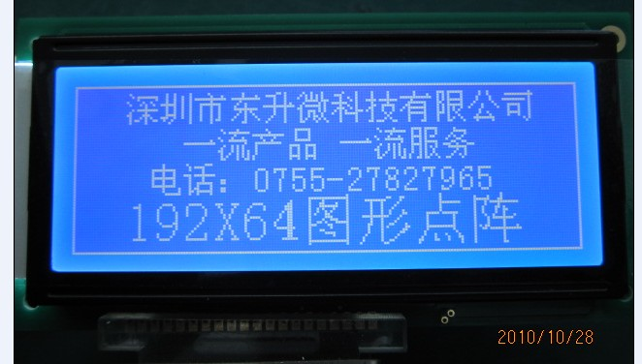

DS19264-5使用手册

目 录
序号 | 内 容 | 页码
 | 封面 | 1
 | 目录 | 2
1 | 模块简介 | 3
2 | 外形及接口图 | 4
3 | 引脚及说明 | 5
4 | 硬体框图 | 6
5 | 电气参数 | 7
6 | 极限参数 | 7
7 | 光电特性 | 8
8 | 时序特性 | 9～10
9 | 功能说明 | 11~16
10 | 模块使用注意事项 | 17

1 模块简介
1.1 规格
模块尺寸: 130.0(W)×65.0(H)×13.O (T)(mm)
显示视域：Area: 104.0(W)×39.0(H)(mm)
点 大 小: 0.458W)×0.458(H)(mm)
点 间 距: 0.41(W) ×0.41(H)(mm)
1.2 特点
点 阵 数：192X64Dots
控 制 器 IC: KS 0107
数据显示RAM: 512×8=4096 Bits
驱动方式: 1/64 Duty; 1/9 Bias
LCD模式: STN-蓝膜负显
视 角：6 O’clock
背 光源：LED
背光源颜色：白色
工作温度:正常情况为:0℃ ~50℃(最宽的工作温度为:-20℃ ～70℃)
储存温度:正常情况为:-10℃ ~60℃(最宽的储存温度为:-30℃ ～80℃)
可靠性：寿命为50000小时以上（25℃）

外形尺寸及接口图
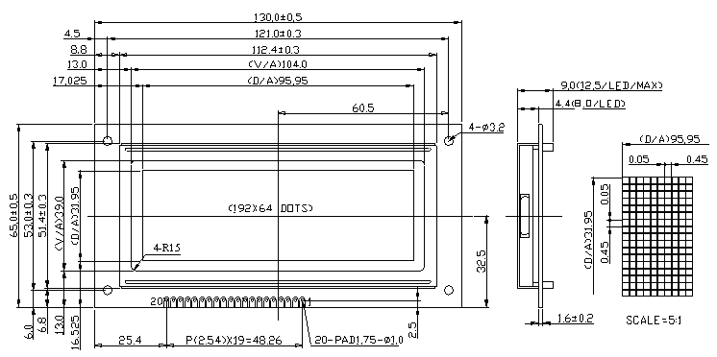

对比度电压调法：用20K电位器 中间接VO 另外接VOUT 或 VSS（地）

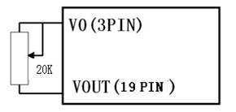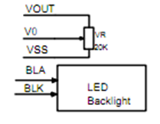

3 外形尺寸及接口图
Pin NO. | Symbol | Function
1 | VSS/GND | Ground
2 | VDD | Power Supply Voltage for Logic and LCD
3 | V0 | Supply Voltage for LCD (Low Voltage)
4 | RS | Data/Instruction Select. 1: Data; 0: Instruction
5 | R/W | Read/Write Select. 1: Read; 0: Write
6 | E | Enable Signal. Data is latched at the Falling Edge of E
7 | DB0 | Data Bus
8 | DB1 | Data Bus
9 | DB2 | Data Bus
10 | DB3 | Data Bus
11 | DB4 | Data Bus
12 | DB5 | Data Bus
13 | DB6 | Data Bus
14 | DB7 | Data Bus
15 | CS1 | SEG Driver A Select
16 | RST | System Reset
17 | CS2 | SEG Driver Select B
18 | CS3 | SEG Driver Select C
19 | VEE/VOUT | Negative Voltage for LCD Driving
20 | VBLk | Power Supply for LED Backlight
4 ABS0LUTE最大额定值

4.1 电气参数（工作电压3.3 5.0V）
Item | Symbol | Standard Value |  | Unit | Condition
Item | Symbol | Min. | Max. | Unit | Condition
Power supply Voltage | VDD-VSS | 0 | 7 | V
LCD Driving Voltage | VDD-VEE | VDD-19.0V | VDD+0.3V | V
Input Voltage | VIN | VEE-0.3V | VDD+0.3V | V
Static Electricity | - | - | 100 | V
Operating Temperature Range | TOP | 0 | +50 | ℃
Storage Temperature Range | TST | -10 | +60 | ℃

4.2 Environmental Absolute Ratings
Item | TST |  | TOP |  | Remark
Item | Min. | Max. | Min. | Max. | Remark
Ambient Temperature | -10℃ | +60℃ | 0℃ | +50℃ | Note 1)
Humidity | Note 2) |  | Note 2) |  | No Condensation
Vibration | - | 4.9m/s² | - | 19.6m/s² | 3 Directions (X/Y/Z)
Shock | - | 29.4m/s² | - | 490m/s² | 6 Directions (±X±Y±Z)
Note 1) Care should be taken so that the LCD module may not be subjected to the temperature out of this specification.
Note 2) Ta≤40℃: 90% RH Max
Ta＞40℃: Absolute humidity shall be less than Ta=40℃/90% RH.

5 BLOCK DIAGRAM
Module internal set description:
※ Data shift direction : C1→C64;
※ Relation between Y address of display RAM and LCD segment: Y0/S1→Y63/S64
※ Data shift at the rising edge of CL2;
※ The oscillation frequency: fOSC=430KHz;
※ Internal set CS1=0, CS3=1(VDD), and CS2 be connecting to module interface, CS2=1: chip selection.

6 ELECTRICAL CHARACTERISTICS

6.1 DC Characteristics
Ta=25℃, VDD=5V±10%, VSS=OV
Item | Symbol | Standard Value |  |  | Unit | Condition
Item | Symbol | Min. | Typ. | Max. | Unit | Condition
Power Supply Voltage | VDD | 3.3 | 5.0 | 5.5 | V
LCD Driving Voltage | VO | - | -10.0 | - | V
Input high Voltage | VIH | 0.7×VDD | - | VDD | V
Input Low Voltage | VIL | 0 | - | 0.3×VDD | V
Power Supply Current | IDD | - | 20 | - | mA
LCD Power Supply Current | I0 | - | 0.8 | - | mA

6.2 AC Characteristics
Item | Signal | Symbol | Min | Max | Unit
E Cycle | E | tC | 1000 | - | ns
E High Level Width | E | tWH | 450 | - | ns
E Low Level Width | E | tWL | 450 | - | ns
E Rise Time | E | tR | - | 25 | ns
E Fall Time | E | tF | - | 25 | ns
Address Setup Time | R/W, CS, RS | tAS | 140 | - | ns
Address Hold Time | R/W, CS, RS | tAH | 10 | - | ns
Data Setup Time | DB0~DB7 | tDS | 200 | - | ns
Data Delay Time | DB0~DB7 | tDD | - | 320 | ns
Data Hold Time (Write) | DB0~DB7 | tDHW | 10 | - | ns
Data Hold Time (Read) | DB0~DB7 | tDHR | 20 | - | ns

7 OPTICAL CHARACTERISTICS
Item | Symbol | Min. | Typ. | Max. | Unit | Condition | Note
Viewing Angle | θ2-θ1 | 70 | 90 | 120 | Deg. | Cr=2.0 | 1,2
Viewing Angle | Φ | -90 | 0 | +90 | Deg. | Cr=2.0 | 1,2
Contrast Ratio | Cr | - | 4 | - | - | θ=20˚; Φ= 0˚ | 3
Response Time (rise) | Tr | - | 250 | - | ms | θ=20˚; Φ= 0˚ | 4
Response Time (fall) | Tf | - | 350 | - | ms | θ=20˚; Φ= 0˚ | 4
- Above data are measured under 1/64 duty STN-Yellow Green mode
- Φ= 0˚ means viewing direction
Note 1: Definition of viewing angle θ & Φ | Note 2: Definition of viewing angle θ2 & θ1
Note 3: Definition of contrast Cr | Note 4: Definition of optical response

8 FUNCTIONAL DESCRIPTION
8.1 Interface Control
8.1.1 I/O Buffer
Data is transferred through 8 data bus lines (DB0~DB7).
DB7: MSB (Most significant bit); DB0: LSM (Least significant bit)
Data can neither be input nor output unless CS1 to CS3 are in the active mode. When CS1 to CS3 are not active mode the internal state is maintained and no instructions executes. Besides, pay attention to RST and ADC which operate irrespectively of CS1 to CS3.
8.1.2 Register
△ Input register
The input register is used to store data temporarily before writing it into display data RAM (automatically by internal operation). When CS1to CS3 are in the active mode and RS and R/W select the input register as shown in table, data is latched at the fall of the E signal.
△ Out register
The output register is used to store data temporarily that is read from display data RAM. To read out the data from output register, CS1 to CS3 should be in the active mode and both RS and R/W should be 1as shown in table.
Register Selection Table
D/I | R/W | Operation
1 | 1 | Reads data out of output register as internal operation(DD RAM→Output register)
1 | 0 | Writes data into input register as internal operation(Input register→DD RAM)
0 | 1 | Busy check. Read of status data
0 | 0 | Instruction
8.2 Busy Flag
Busy Flag = 1 indicates the IC is operating and no instructions except status read instruction can be accepted. The value of the busy flag is read out on DB7 by the status read instruction.

8.3 Display ON/OFF Flip/Flop
The display on/off flip/flop selects one of two states, on state and off state of segments S1 to S64. In on state, the display data corresponding to that in RAM is output to the segments. On the other hand, the display data at all segments is disappeared in off state independent of the data in RAM.
RST=0 sets the segment in 0ff state. The status of the flip/flop is output to DB5 by status read instruction. To control display data latch by this flip/flop, CL signal should be input.
Display on/off instruction does not influence data in RAM.
8.4 Display Start Line Register
The display start line register specifies the line in RAM, which corresponds to the top line of LCD panel, when displaying contests in display data RAM on the LCD panel.
6-bit display start line information is written into this by the display start line set instruction. When high level of the FRM signal starts the display, the information in this in this register is transferred to the Z address counter, which controls the display address, presetting the Z address counter.
8.5 X, Y Address Counter
A 9-bit counter which designates address of the internal display data RAM. X address counter(upper 3 bit) and Y address counter (lower 6 bit) should be set to each address by the respective instruction.
X address counter
Ordinary register with no count functions. An address is set by instruction.
Y address counter
An address is set by instruction and is increased by 1 automatically by R/W operations of display data. The Y address counter loops the values of to 63 to count.
8.6 Display Data RAM
Stores dot data for display. 1-bit data of this RAM corresponds to light on(data=1)and light off(data=0)of 1 dot in the LCD display panel. The correspondence between Y addresses of RAM and segment pins can be reversed by ADC signal.
Note: ADC=1(ADC connect VDD) of the module internal circuit set.

Figure: Relation between RAM Data and Display

8.7 Z Address Counter
The Z address counter generates addresses for outputting the display data synchronized with the common signal. This counter consists of 6 bits and counts up at the fall of the CL signal. At the high level of FRM, the contents of the display start line register is preset at the Z counter.
8.8 Bi-directional Shift Register
A 64-bit bi-directional shift register. The data is shifted from DL to DR when SHL is at high level and from DR to DL when SHL is at low level. In this case, CL2 is used as shift clock. The lowest order bit of the bi-directional shift register, which is on the DL side, corresponds to C1, and the highest order bit on the DR side corresponds to C64.
Note: SHL=1(SHL connect VDD) of the module internal circuit set.
8.9 Display Data Latch
The display data latch stores the display data temporarily that is output from display data RAM to the liquid crystal driving circuit. Data is latched at the rise of the CL signal. The display on/off instruction controls the data in this latch and does not influence data in display data RAM.
8.10 Timing generator Circuit
The timing generator circuit generates display timing and operating clock.
8.11 Liquid Crystal Display Driver Circuit
The combination of latched display data and M signal causes one of the 4 liquid crystal driver levels, V1, V2, V3 and V4 to be output.
The combination of the data from the shift register with the M signal allows one of the four liquid crystal display driver levels V1, V2, V5 and V6 to be transferred to he output terminals
Data of latched (columns) / Data from the shift register (lines) | M | Output Level
 | M | Segment | Common
1 | 1 | V1 | V2
0 | 1 | V3 | V6
1 | 0 | V2 | V1
0 | 0 | V4 | V5
8.12 Reset
The system can be initialized by setting RST terminal at low level when turning power on.
While RST is low level, no instruction except status read can be accepted. Therefore, execute other instructions after making sure that DB4=0(clear RESET) and DB7=0(Ready) by status read instruction. The conditions of power supply at initial power up are shown in table.

9 Instructions

9.1 Instructions table
Instruction | Code |  |  |  |  |  |  |  |  |  | Function
Instruction | RS | R/W | D7 | D6 | D5 | D4 | D3 | D2 | D1 | D0 | Function
Display ON/OFF | 0 | 0 | 0 | 0 | 1 | 1 | 1 | 1 | 1 | 0/1 | Controls the Display ON or OFF.  Internal Status and Display RAM Data are not Affected.  L:OFF; H:ON
Set Address  (Y-Address) | 0 | 0 | 0 | 1 | Y-Address (1~64) |  |  |  |  |  | Set the Y-Address in the Y counter
Set Page  (X-Address) | 0 | 0 | 1 | 0 | 1 | 1 | 1 | Page (0~3) |  |  | Set the X-Address in the X-Address Register
Display Start Line  (Z-Address) | 0 | 0 | 1 | 1 | Display Start Line (1~64) |  |  |  |  |  | Determines the Display Data RAM Displayed at the top of the Screen
Statue Read | 0 | 1 | BUSY | 0 | ON/OFF | RESET | 0 | 0 | 0 | 0 | Read the Status  BUSY=0: Ready;  BUSY=1: In Operation;  ON/OFF=1: Display Off;  ON/OFF=0: Display On;  RESET=1: Reset;  RESET =0: Normal
Write  Display Data | 1 | 0 | Write Data |  |  |  |  |  |  |  | Write Data (DB0~DB7) to the Display Data RAM.  After Writing Instruction, Y-Address Automatically Incremented by 1.
Read  Display Data | 1 | 1 | Read Data |  |  |  |  |  |  |  | Read Data (DB0~DB7) from Display Data RAM to the Data Bus.
9.2 Explanation of Instruction Code
9.2.1 Display On/Off
 | RS | R/W | DB7 | DB6 | DB5 | DB4 | DB3 | DB2 | DB1 | DB0
Code | 0 | 0 | 0 | 0 | 1 | 1 | 1 | 1 | 1 | D
This command turns the display on and off.
D=0: Display On; D=1: Display Off
9.2.2 Display Start Line
 | RS | R/W | DB7 | DB6 | DB5 | DB4 | DB3 | DB2 | DB1 | DB0
Code | 0 | 0 | 1 | 1 | A | A | A | A | A | A
9.2.3 Set Address (Y-Address)
 | RS | R/W | DB7 | DB6 | DB5 | DB4 | DB3 | DB2 | DB1 | DB0
Code | 0 | 0 | 0 | 1 | AC5 | AC4 | AC3 | AC2 | AC1 | AC0
This command loads the display start line register.
9.2.4 Set Page (X- Address)
 | RS | R/W | DB7 | DB6 | DB5 | DB4 | DB3 | DB2 | DB1 | DB0
Code | 0 | 0 | 1 | 0 | 1 | 1 | 1 | AC2 | AC1 | AC0
This command loads the page address register.
9.2.5 Read Status
 | RS | R/W | DB7 | DB6 | DB5 | DB4 | DB3 | DB2 | DB1 | DB0
Code | 0 | 1 | BUSY | 0 | ON/OFF | RESET | 0 | 0 | 0 | 0
Reading the command I/O register (A0=0) yields system status information.
BUSY: BUSY=1 indicate the operating or Reset cycle.
he instruction can be input after the BUSY status change to “0”.
ON/OFF: Indicate the whole display ON/OFF status.
0: Whole Display “ON”; 1: Whole Display “OFF”
RESET: Indicate the initialization period by RST signal or reset instruction.
0: Currently executing reset command; 1: Initialization Period
9.2.6 Write Display Data
 | RS | R/W | DB7 | DB6 | DB5 | DB4 | DB3 | DB2 | DB1 | DB0
Code | 1 | 0 | Write data
Writes 8-bits of data into the display data RAM, at a location specified by the contents of the column address and page address registers and then increments the column address register by one.
9.2.7 Read Display Data
 | RS | R/W | DB7 | DB6 | DB5 | DB4 | DB3 | DB2 | DB1 | DB0
Code | 1 | 1 | Read data
Reads 8-bits of data from the I/O latch, updates the contents of the I/O latch with display data from the display data RAM location specified by the contents of the column address and page address registers and then increments the column address register.
After loading a new address into the column address register one dummy read is required before valid data is obtained.
10 PRECAUTIONS IN USE OF LCM
10.1 Handing of LCM
(1). LCM may be broken because it is made of glass. In case the liquid crystal touches human hand, skin, eye and cloth, must use water to wash it out thoroughly and immediately.
(2). Leave the module in its package bag before use it.
(3). Keep the module operated or storage within specified temperature and humidity range.
(4). Polarize is a soft material and can easily be scratched.
(5). Please avoid static electricity.
(6). Do not touch the connection rubber or heat seal, nor modify the location.
7). Do not move the tab of the metal holder nor make any rearrangement to it.
10.2 Storage
(1). Store in an ambient temperature of 5 to 35℃ and in a relative humidity of 40 to 60%.
(2). If you store as unpacked, put in anti-static bag, seal its opening and store where it is not subjected to direct sunlight and fluorescent lamp.
10.3 Installing
(1). Do not take off the protective firm attached on display surface.
(2). Leave enough height to avoid stressing to the surface. A measurement tolerance ±0.1mm is necessary.
(3). Do not directly mark on the PCB while soldering the connector or cable.
4). Soldering iron, no higher than 260℃ and less than 3-4 second during soldering.
(5). Connector rework soldering, no more than 3 times.

